**Assignment # 1**



**Fall 2024**

**CSE-411 Intro to Game Development**

Submitted by: **Ali Asghar**

Registration No.: **21PWCSE2059**

Class Section: **A**

“On my honor, as student of University of Engineering and Technology, I have neither given nor received unauthorized assistance on this academic work.”

Submitted to:

**Engr. Abdullah Hamid**

Date:

23**rd October 2024**

**Department of Computer Systems Engineering**

**University of Engineering and Technology, Peshawar**

**Task:**

Download free assets/packages from Unity Asset Store and import them to a project and use them in a scene, explain the method step by step using screen shots and text.

**Solution:**

**Step 1:**

I first went to the Unity Asset Store and logged in using my Unity account. I searched for free assets by typing keywords related to what I needed in the search bar. The Asset Store allows filtering results by categories such as 3D, Audio, or Tools, which made it easier for me to find exactly what I was looking for. I found a free asset package called Projectile Curve Visualizer shown in figure below.

**Step 2:**

I clicked on it to check its description, ratings, and reviews. Once I was sure it met my needs, I added it to my account and then I clicked the **Open in Unity** button to see this package in the package manager inside unity. I clicked the **download** button to get the actual package file of this asset.

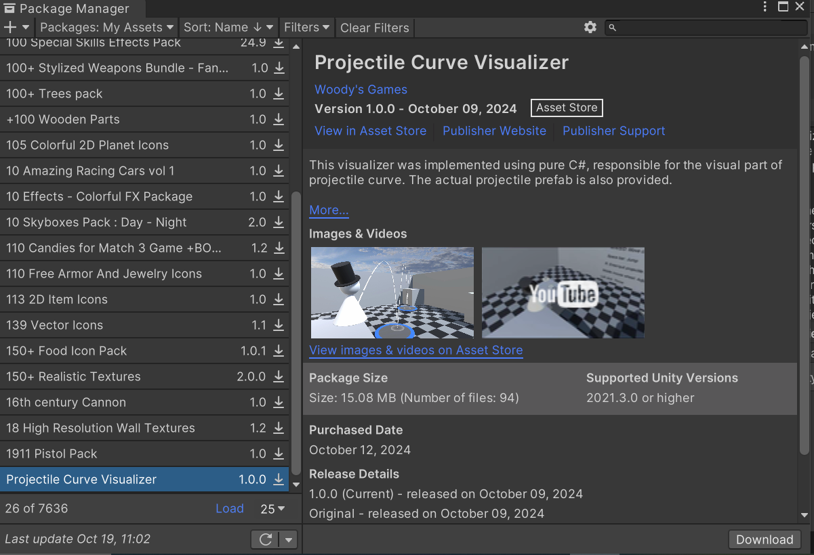

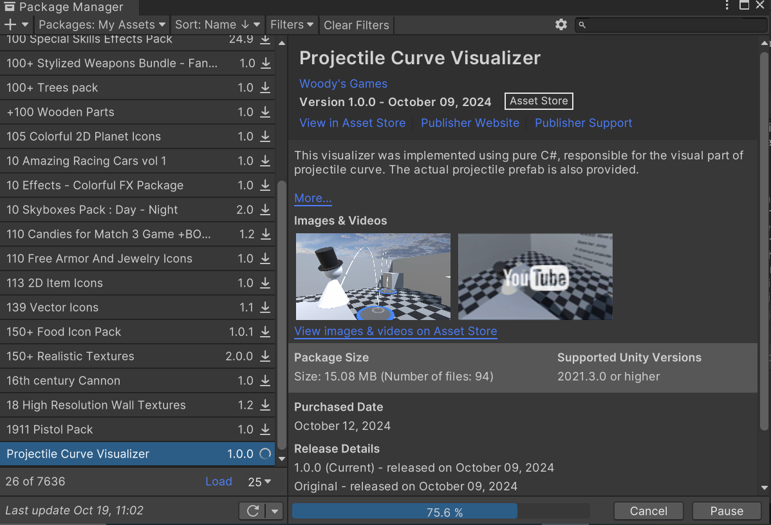

**Step 3:**

Once I hit Import, Unity showed a list of all the files included in the asset package. I selected the files I needed and clicked Import again to add the assets to my project.

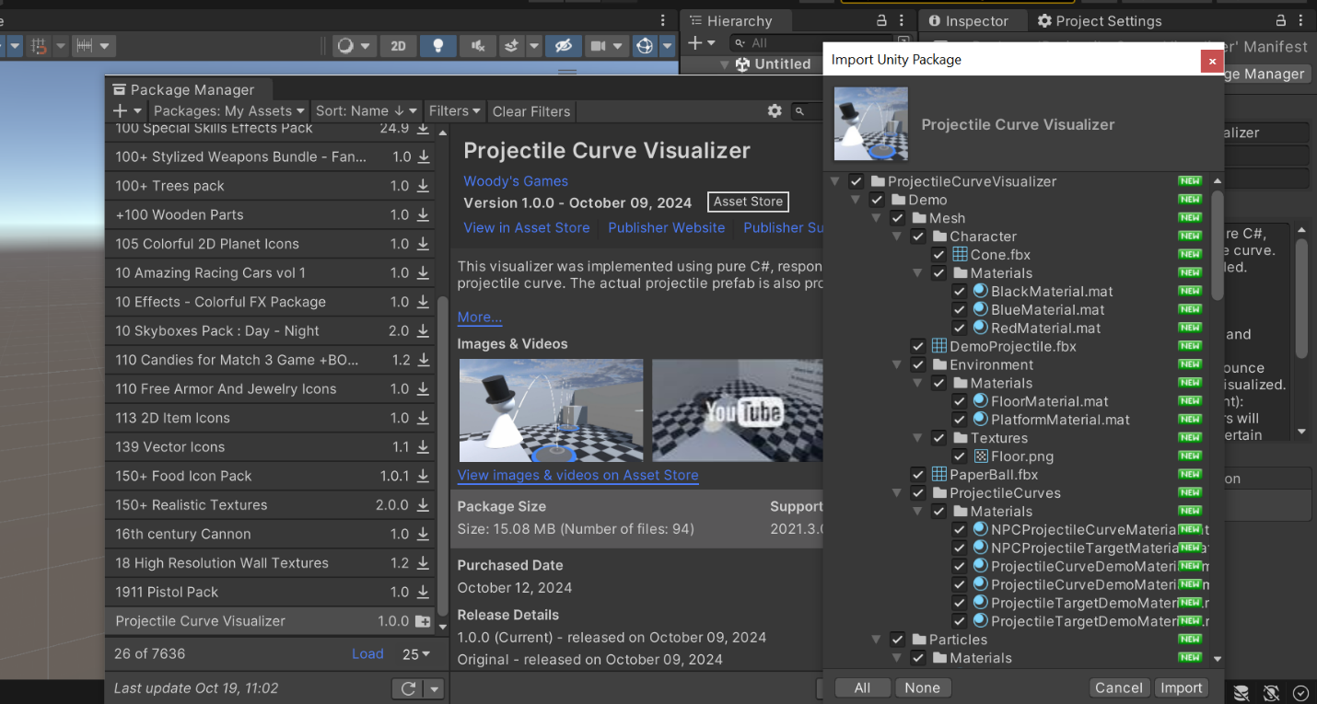

**Step 4:**

I was able to see the imported assets in the Project window. I could then simply drag and drop them into my Scene to start using them.

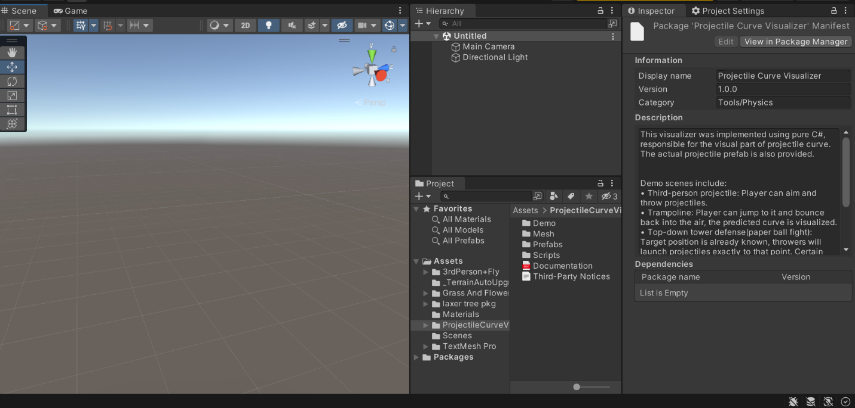

**Step 5:**

I navigated to the demo scenes of this asset. It’s always good practice to see some demos before using the assets in a project.

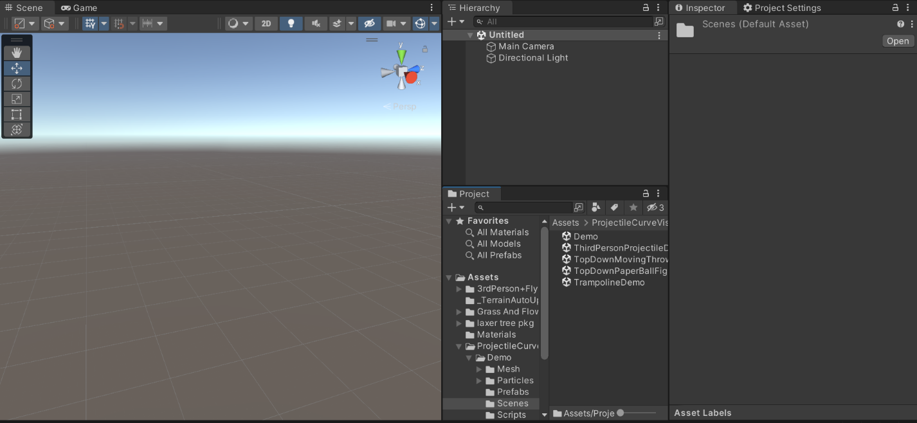

**Step 6:**

I opened the Third Person Projectile Demo Scene and understood the working of this package.

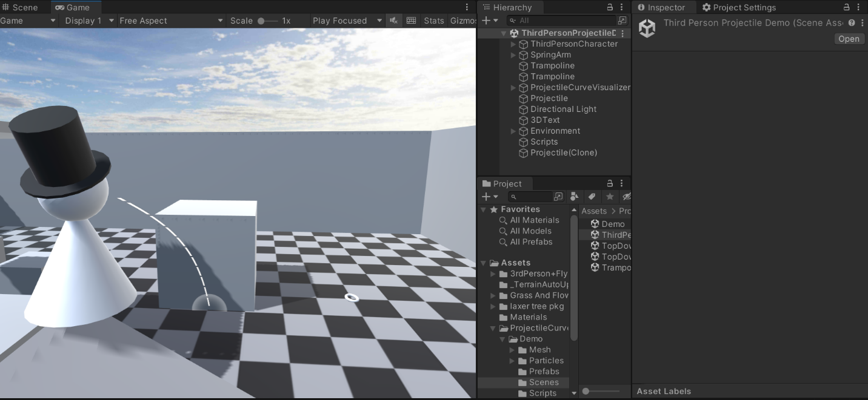

**Step 7:**

Finally, after playing around with the demos, I got the idea of how to integrate this free package with my own game scene. I dragged the contents of Third Person Projectile Demo Scene into my terrain scene from lab 3. Now I have this character in my scene which can throw projectiles.



